How to login as “I AM USER” on koolabs Huaweicloud ID

After login

This view will be show

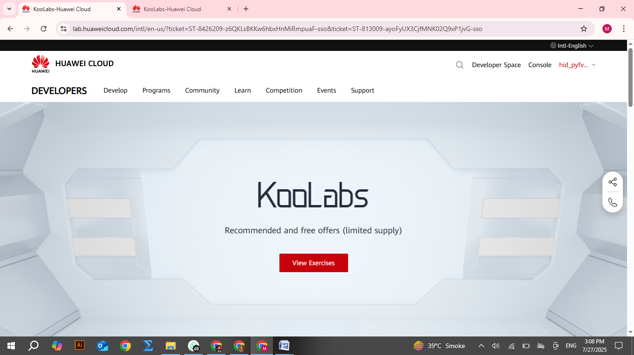

Clicks-on “View Exercise”

Then shows

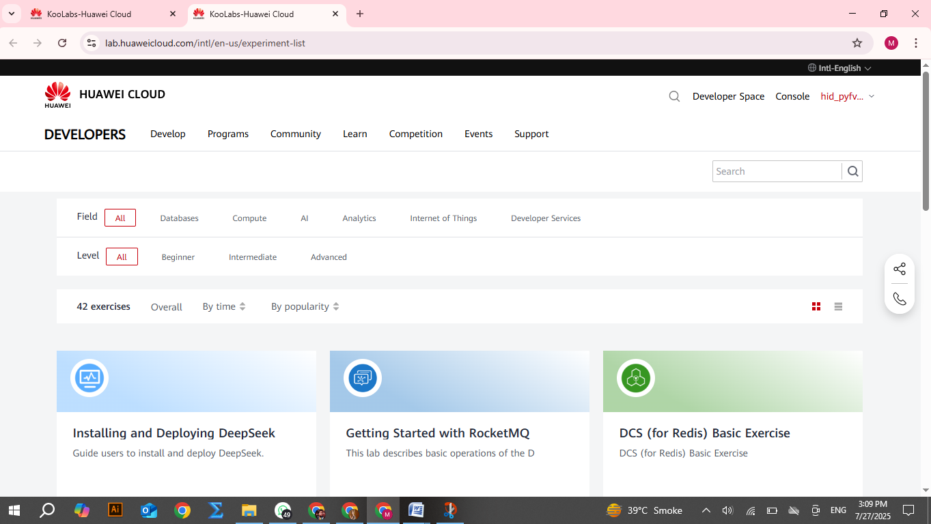

Then clicks-on installind and Deploying DeepSeek

Then show

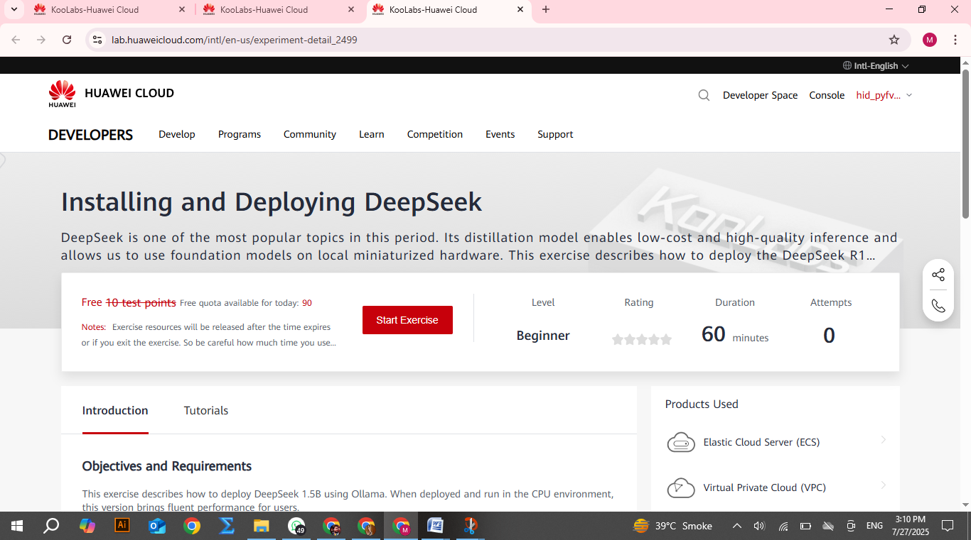

After this clicks-on “start exercise”

Then show

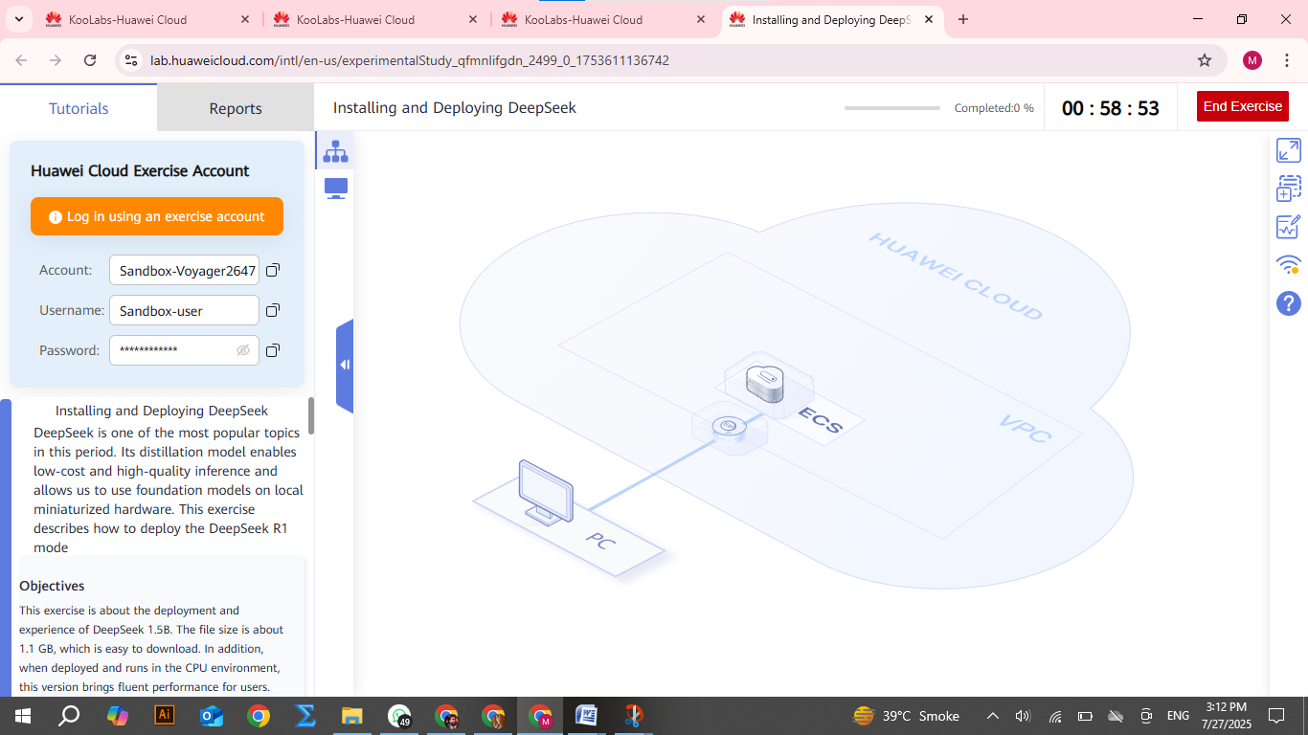

After this view clicks-on “PC icon at the top left corner”

Then show

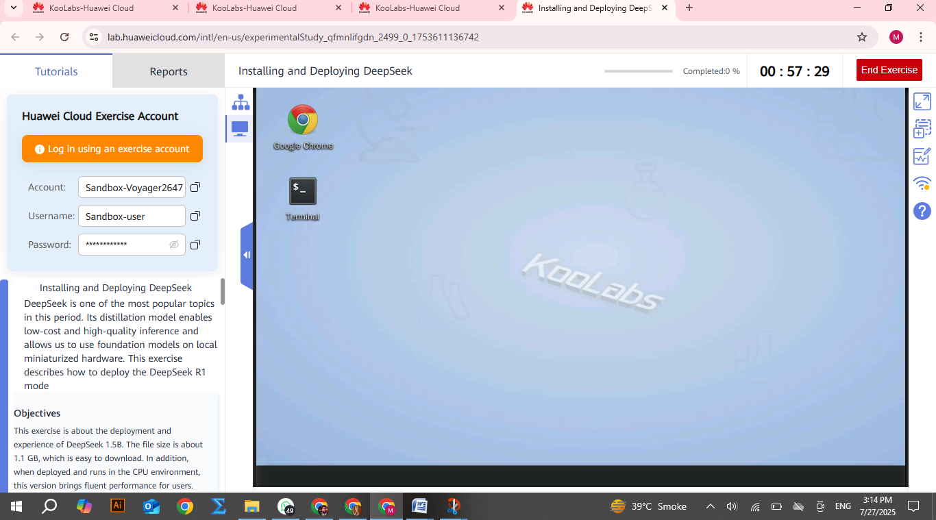

After this view clicks-on “google chrome”

And show this

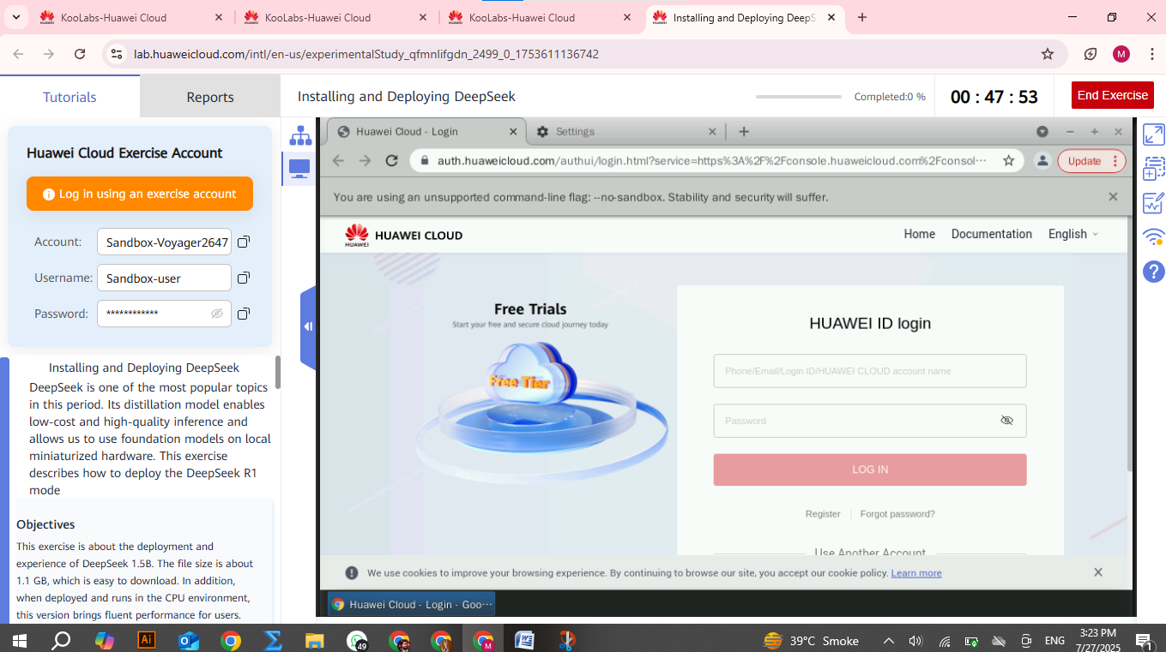

**Select “I AM USER”**

**Then copy details of Sandbox Details given above left corner**

**Account**

**Username**

**Password**

And paste in the required detail on browser on right side.

**Create VPC**

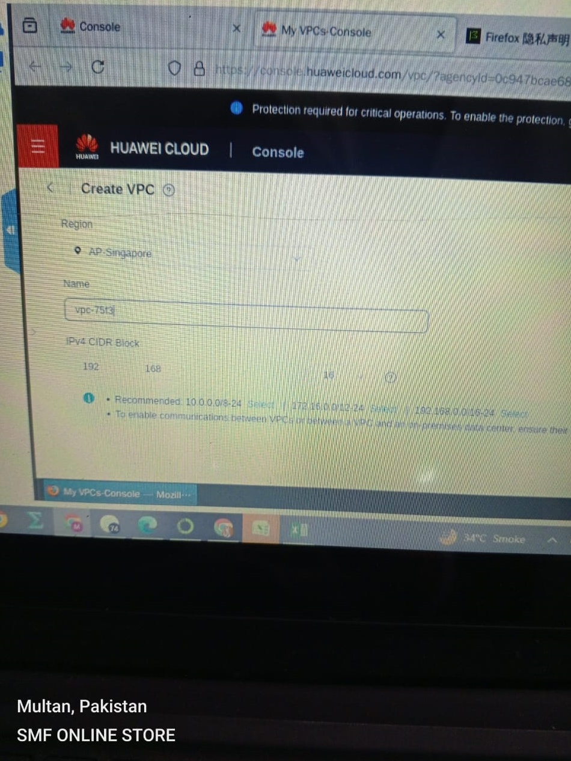

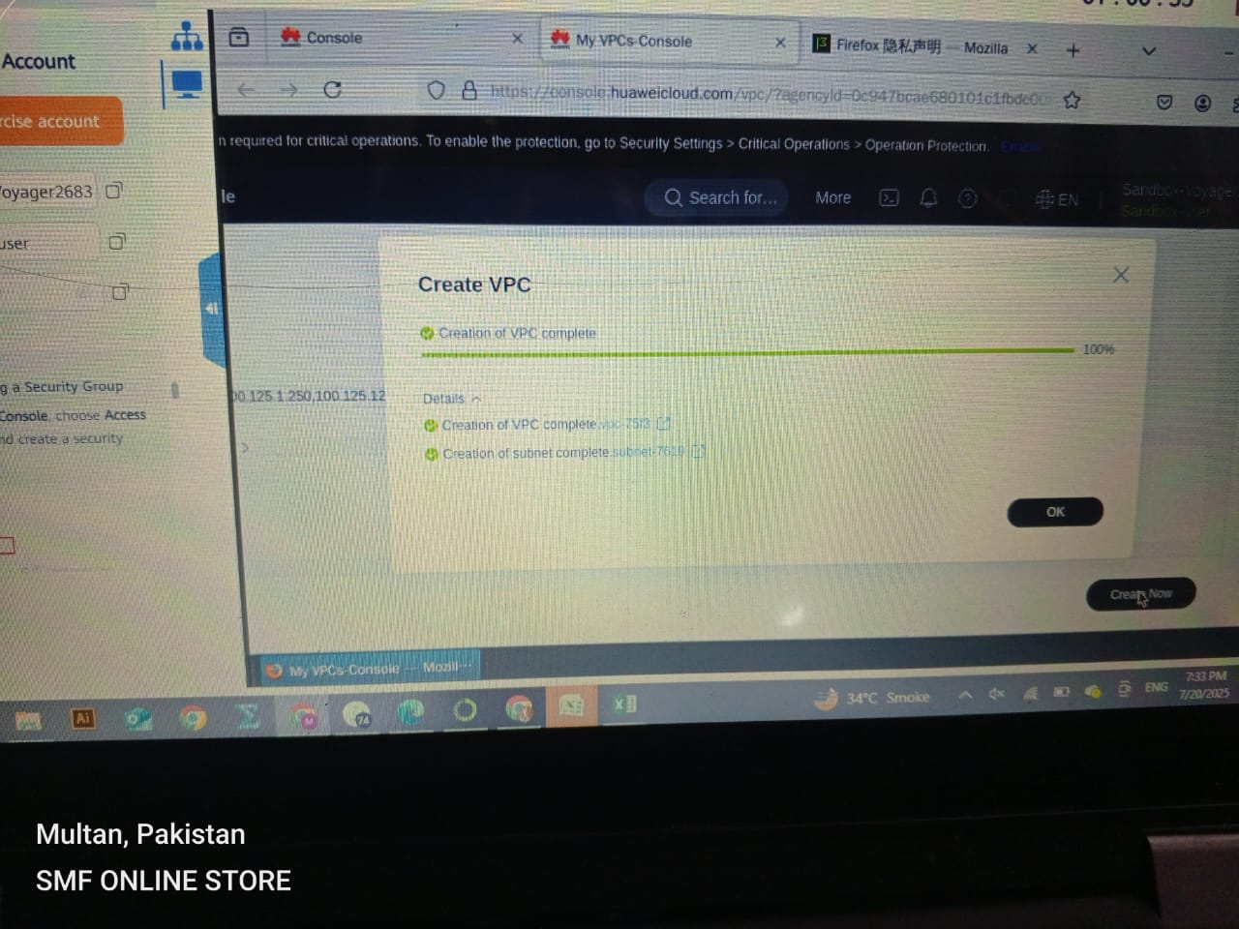

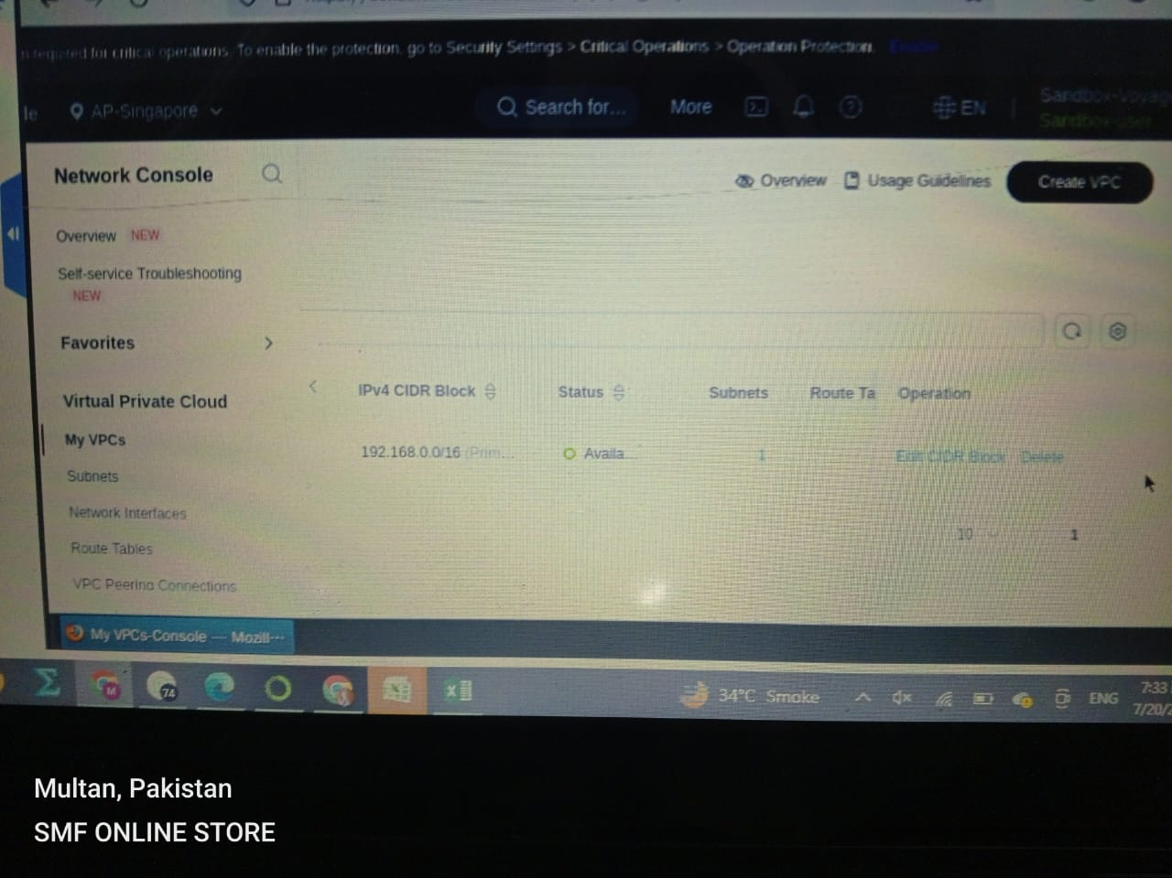

**Now creating “Bucket” from OBS Bucket manager**

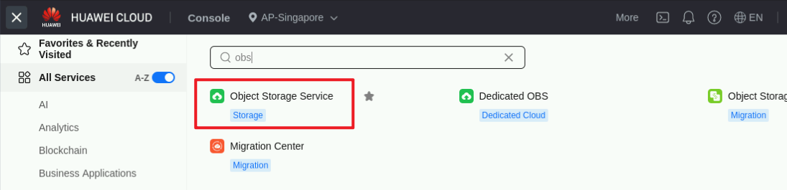

**4 Options** are included in creating a bucket at cloud

1. Bucket name
2. Create for “multi a-z user” , or “single a-z user”
3. Bucket “public’ or “private”
4. Cheque “encryption” or not

Click **Create Bucket** to access the creation page.

